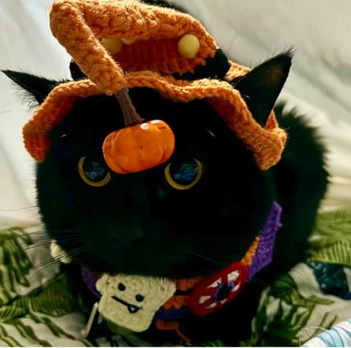

PIF Rescue Dossier: Viper

Meet Viper
Viper is my girl, and helping her find a new home is an incredibly difficult decision. I love her dearly, but I also know that the kindest thing I can do is put her happiness first.
Viper is a deeply affectionate cat who forms a special bond with her people. She can be fearful of unfamiliar people and will usually hide when someone new is around. Once she knows and trusts you, however, she is friendly, devoted, and incredibly loving. She craves attention, adores being petted and loved on, and especially loves chin scratches.

Why Viper Is Being Adopted Through PIF
Since our move from New York, Viper simply hasn’t been happy sharing her home with other animals. We worked with our veterinarian and tried medication in hopes of easing her stress, but it left her overly sedated and miserable rather than helping her feel like herself.
After trying to make things work, I have had to accept that Viper needs something I cannot provide in our current home: the chance to be the only animal. She does not get along with other cats or dogs, and living with them causes her too much stress.
Viper is being adopted through PIF because I want to ensure that she finds the right home—one where her needs are understood and she can finally feel peaceful, secure, and happy.

Viper’s Ideal Home
Viper needs a calm, stable home without other animals. She will thrive as her adopter’s one and only companion, receiving the space, security, and attention she needs.
Her adopter should understand that trust may take time. Viper may hide while she adjusts to unfamiliar people and surroundings, but patience will be rewarded with a remarkably loving and devoted companion.

A Note From Me
Letting Viper go will break my heart, but keeping her in an environment where she is unhappy would be unfair to her. This decision is not being made because she is unloved. It is being made because I love her enough to put her well-being ahead of my own feelings.
Viper deserves a home where she can relax, be herself, and have her people—and all the chin scratches—to herself. My greatest hope is to find someone who will love and cherish my girl as deeply as I do.

